|  |  |
| --- | --- |
| **EX.NO:10** | **E-BOOK MANAGEMENT SYSTEM** |

SEQUENCE DIAGRAM:

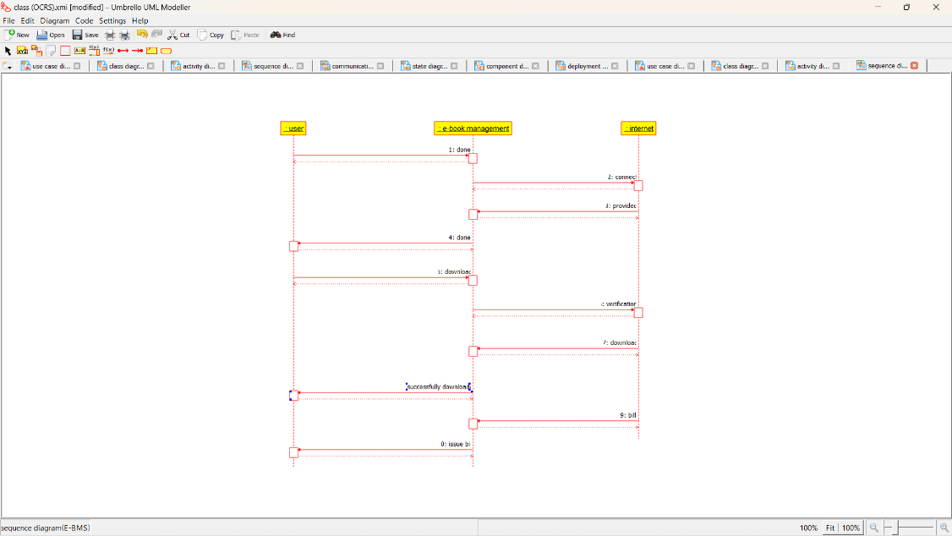

COLLABORATION DIAGRAM: 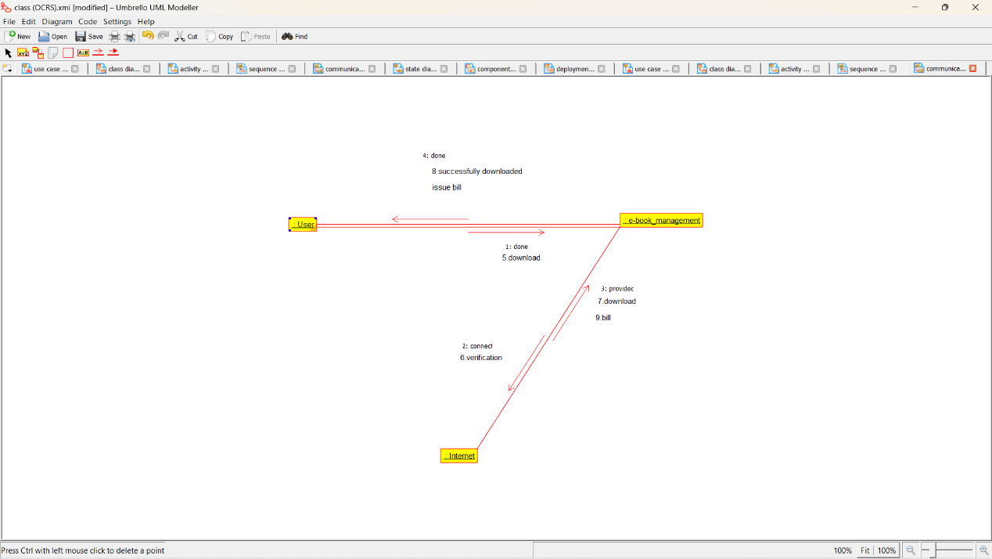

COMPONENT DIAGRAM: 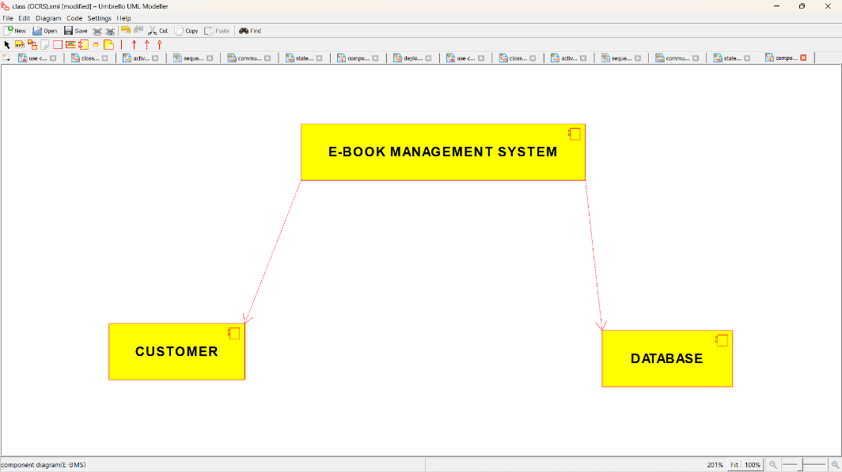

DEPLOYMENT DIAGRAM:

